Java Programming
Section 4.3 practice
-B. Rishitha
- 192324130

1. Linear Recursion Class

public class Linear {

// Method to compute factorial using recursion
public static double factorial(double n) {
// Base case: factorial of 1 or less is 1
if (n <= 1) {
return 1;
} else {
// Recursive case: n * factorial(n - 1)
return n * factorial(n - 1);
}
}

public static void main(String[] args) {
double d = 5.0;
double result = factorial(d);
System.out.printf("Factorial [%.1f] of [%.1f]%n", result, d);
}
}
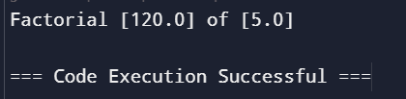
2. Non-Linear Recursion Class
public class NonLinear {

// Method to compute Fibonacci value using recursion
public static double fibonacci(double n) {
// Base cases: Fibonacci of 0 or 1 is the number itself
if (n < 2) {
return n;
} else {
// Recursive case: fibonacci(n - 1) + fibonacci(n - 2)
return fibonacci(n - 1) + fibonacci(n - 2);
}
}

public static void main(String[] args) {
double d;
// Check if arguments are provided
if (args.length > 0) {
d = Double.parseDouble(args[0]);
} else {
d = 5.0;
}

// Print Fibonacci values for the range from 0 to d
for (int i = 0; i <= d; i++) {
System.out.printf("Fibonacci index [%.1f] value [%.1f]%n", (double) i, fibonacci(i));
}
}
}
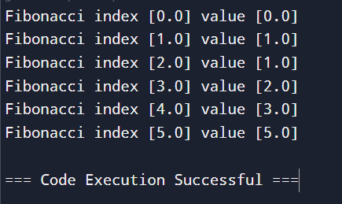
3. Factorial of 7
public class Main {

// Linear class with factorial method
public static class Linear {
public static double factorial(double n) {
// Base case: factorial of 1 or less is 1
if (n <= 1) {
return 1;
} else {
// Recursive case: n * factorial(n - 1)
return n * factorial(n - 1);
}
}

public static void main(String[] args) {
double d = 5.0;
double result = factorial(d);
System.out.printf("Factorial [%.1f] of [%.1f]%n", result, d);
}
}

// NonLinear class with fibonacci method
public static class NonLinear {
public static double fibonacci(double n) {
// Base cases: Fibonacci of 0 or 1 is the number itself
if (n < 2) {
return n;
} else {
// Recursive case: fibonacci(n - 1) + fibonacci(n - 2)
return fibonacci(n - 1) + fibonacci(n - 2);
}
}

public static void main(String[] args) {
double d;
// Check if arguments are provided
if (args.length > 0) {
d = Double.parseDouble(args[0]);
} else {
d = 5.0;
}

// Print Fibonacci values for the range from 0 to d
for (int i = 0; i <= d; i++) {
System.out.printf("Fibonacci index [%.1f] value [%.1f]%n", (double) i, fibonacci(i));
}
}
}

public static void main(String[] args) {
// Run Linear example
Linear.main(args);

// Run NonLinear example
NonLinear.main(args);
}
}
